EXHIBIT "J"

EXHIBIT J-PAGE 1 OF 2

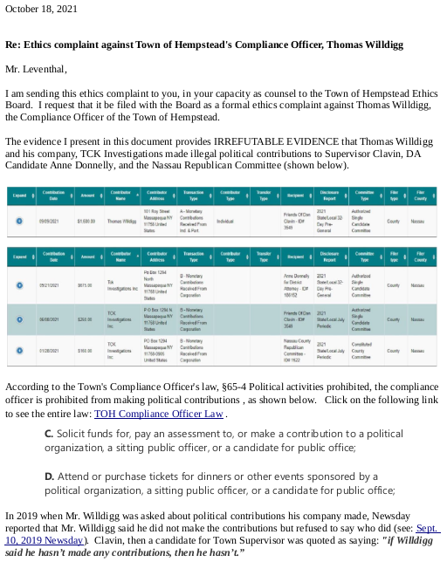

EXHIBIT J-PAGE 2 OF 2

